Complementary Slackness Theorem
- Complementary Slackness Theorem : Suppose that x = (x1, x2, . . . , xn) is primal feasible and that y = (y1, y2, . . . , ym) is dual feasible. Let (w1,w2, . . . ,wm) denote the corresponding primal slack variables, and let (z1, z2, . . . , zn) denote the corresponding dual slack variables. Then x and y are optimal for their respective problems if and only if:
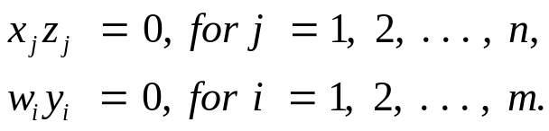
- Proof

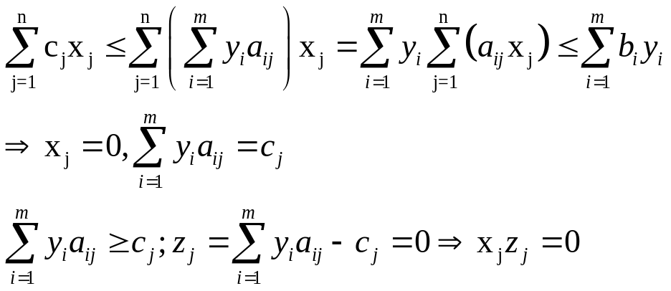

KKT conditions - the karush-kuhn-tucker (kkt) conditions for constrained optimization
- Theorem. Assume that 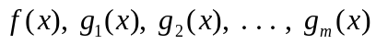 are differentiable functions satisfying certain regularity conditions, then 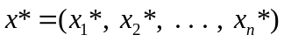 can be an optimal solution for the nonlinear programming problem only if there exist m numbers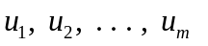 such that all the following KKT conditions are satisfied:
  - 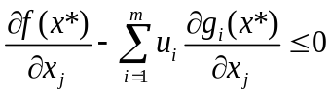
  - 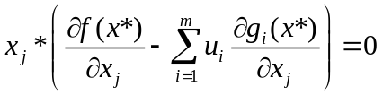 or 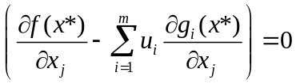 if x can be negative
  - 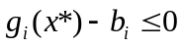
  - Complmentary slackness 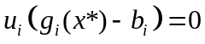
  - Primal and dual feasibility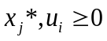
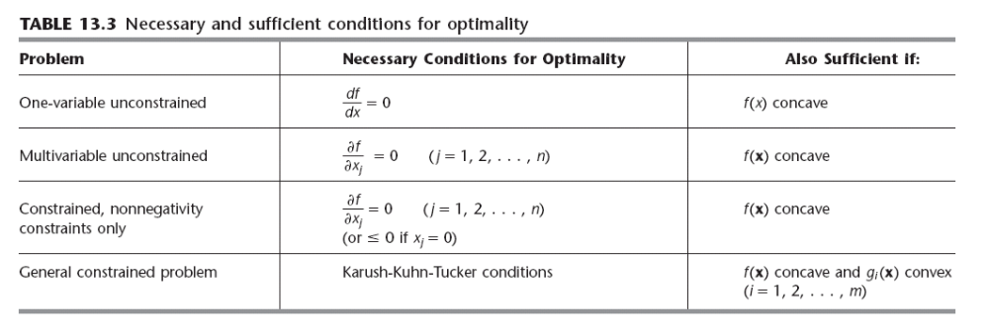

KKT Example:

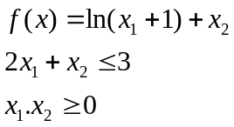
KKT solution:
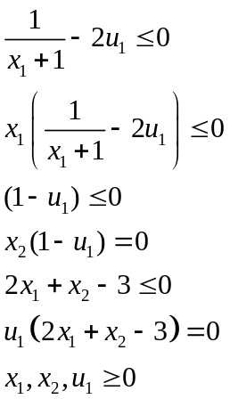
Conlusions
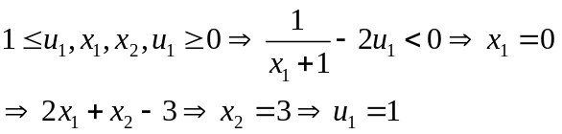

Quadratic Programming and KKT
- Define lagrangian: 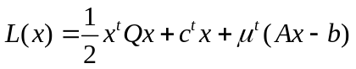
- 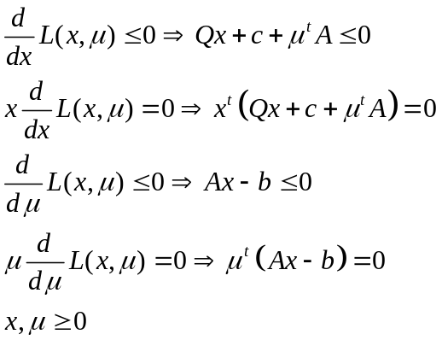
Add slack variables:
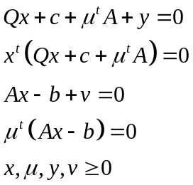

- Examples of nonregular optimal solutions.

Consider the problem Min x s.t. x² ≤ 0, or equivalently
–Max –x s.t. x² ≤ 0.
The feasible region is {x | x=0} and Min {x | x=0} = 0 at x*=0. The point x* is not regular, since ∇g_{E}(x*) = [2x]_{x=0} = [0] which is of rank 0 < |E| = 1.
The KKT conditions do not hold: there exists no μ ≥ 0 such that
∇ƒ(x*) = [- 1] = μ ⋅∇g(x*) = μ . [0].

Notice that x² ≤ 0 is equivalent to x=0, however we must use g(x) = -x² in the KKT conditions.

(2) Consider the problem Min x₁ s.t. x₂ ≤ x₁³, x₂≥ 0.
Then ƒ(x) = -x₁ and g₁(x) = x₂ - x₁³ ≤ 0, g₂(x) = -x₂ ≤ 0.
The solution is x₁*=x₂*=0.
J(x*) = 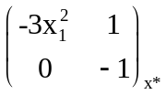 = 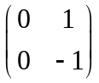 has rank 1<|E|=2, thus x* is not a regular point.

The KKT conditions would require that
∇ƒ(x*) = [-1 0] = μ ⋅∇g(x*) = μ₁ . [0 1] +μ₁ . [0 -1] = [0, μ₁+μ₂]
which is of course impossible. .

Notice however that for the function ƒ(x) = -x₂, the KKT conditions hold at x*, even though it is not a regular point.

One more example of KKT
Consider the problem of minimizing f(x)=4(x-1)²+(y-2)² with constraints:
x + y ≤ 2; x ≥ - 1; y ≥ - 1;
Solution
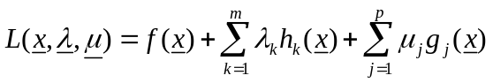:
There are 3 inequality constraints, each can be chosen active/ non active à yield 8 possible combinations. However, 3 constraints together: x+y=2 & x=-1 & y=-1 has no solution, and combination of any two of them yields a single intersection point.
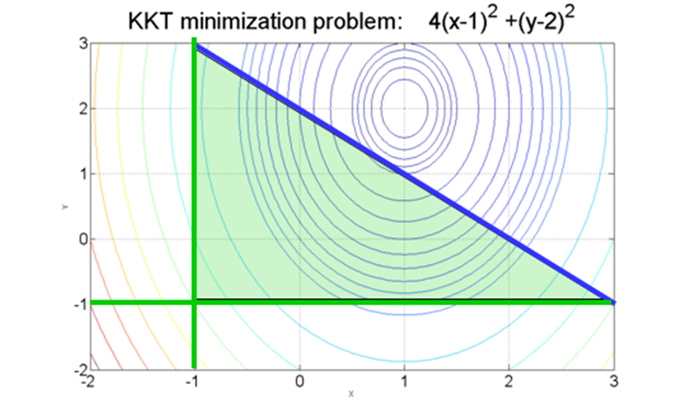
The general case is:
We must consider all the combinations of active / non active constraints:
- 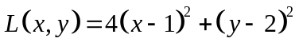
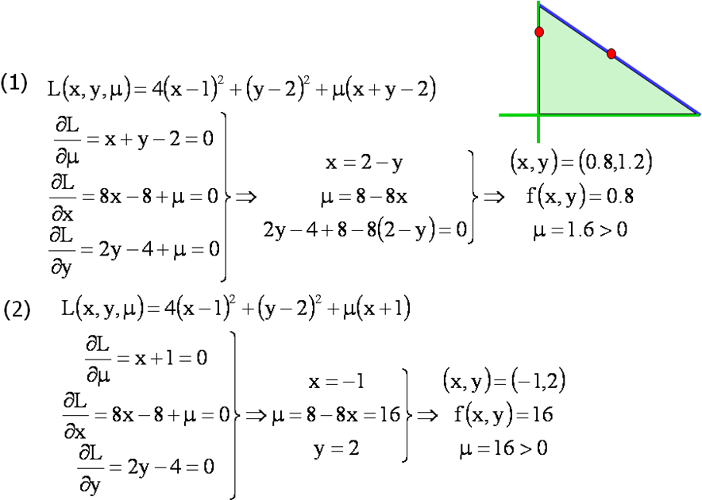
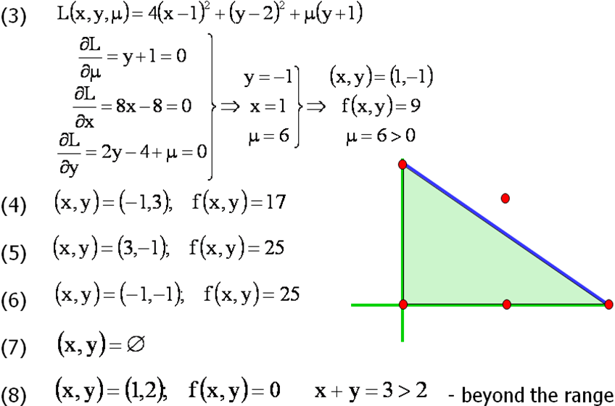

Finally, we compare among the 8 cases we have studied: case (7) resulted was over-constrained and had no solutions, case (8) violated the constraint x+y≤2. Among the cased (1)-(6), it was case (1) ,(x,y)=(0.8,1.2),f(x,y)=0.8, yielding the lowest value of f(x,y).

